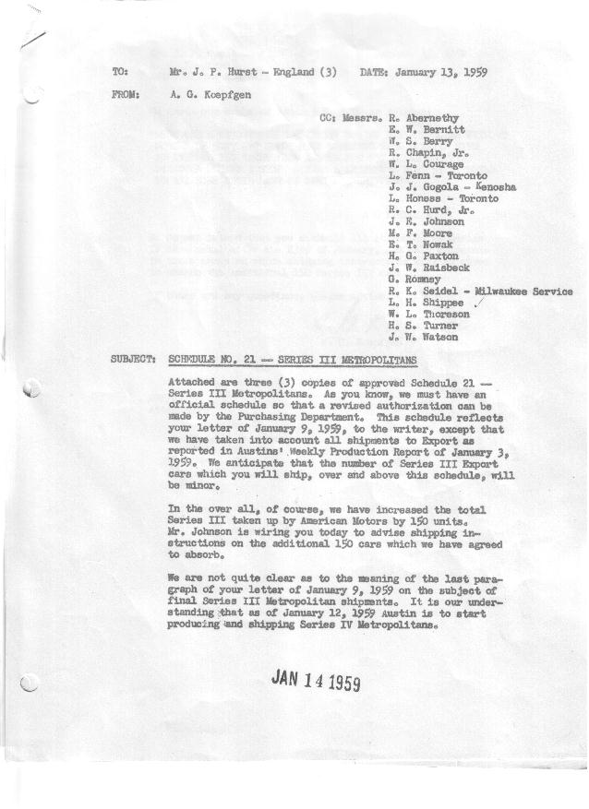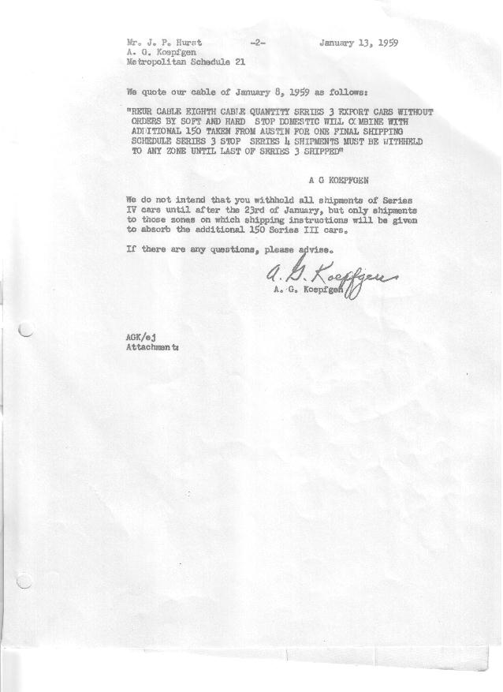

FORM AM 1262 APPROVED R. Abernethy (signed) DATE 1-13-59

SCHEDULE NO. ______21 ___ DATE 1-13-59 MONTHLY BUILDING SCHEDULE APPROVED R. W.Chapin Jr. (signed) DATE_ 1/13/59 _
REVISION NO. _______ ______ DATE PRODUCT APPROVED E.W.Bernitt (signed) DATE _ 1-13-59 ____
FINAL SERIES III 1500 c.c. ENGINE
METROPOLITAN SERIES CARS – AUSTIN MOTORS CO., LTD, ENGLAND
DESCRIPTION | BUILT  ◻ACT EST  THRU | FIRM BUILDING SCHEDULE  (FABRICATED MATERIAL RELEASE) |  |  |  |  |  |  |  |  |  |  |  |  |  |  | TENTATIVE SCHEDULE  (RAW MATERIAL RELEASED) |  |  | GRAND  TOTAL
DESCRIPTION | BUILT  ◻ACT EST  THRU | MONTH JANUARY 1959  DAYS 17 |  |  | MONTH  DAYS |  |  | MONTH  DAYS |  |  | MONTH  DAYS |  |  | MONTH  DAYS |  |  | MONTH  DAYS |  |  | GRAND  TOTAL
DESCRIPTION | BUILT  ◻ACT EST  THRU | DAILY | MONTH | CUM’L  TOTAL | DAILY | MONTH | CUM’L  TOTAL | DAILY | MONTH | CUM’L  TOTAL | DAILY | MONTH | CUM’L  TOTAL | DAILY | MONTH | CUM’L  TOTAL | DAILY | MONTH | CUM’L TOTAL | GRAND  TOTAL
DOMESTIC LHD:
Hard-Top | 28553 |  | 360 | 28913
Soft-Top | 4573 |  | 67 | 4640
Total U.S. | 33126 | 25.1 | 427 | 33553
Over/(Under) Schedule 20 | 69 |  | 147 | 216
FOREIGN:
EXPORT LHD Hard-Top | 835 |  | -0- | 835
Soft-Top | 388 |  | -0- | 388
Total Export LHD | 1223 |  | -0- | 1223
RHD Hard Top | 355 |  | -0- | 355
Soft Top | 60 |  | -0- | 60
Total Export RHD | 415 |  | -0- | 415
Total Export LHD & RHD | 1638 | 0.0 | -0- | 1638
Over/(Under) Schedule 20 | (125) |  | -0- | (125)
CANADA Hard-Top | 2614 |  | -0- | 2614
Soft-Top | 242 |  | -0- | 242
Total Canada | 2856 | 0.0 | -0- | 2856
Over/(Under) Schedule 20 | 59 |  | -0- | 59
Total Foreign | 4494 | 0.0 | -0- | 4494
Over/(Under) Schedule 20 | (66) |  | -0- | (66)
GRAND TOTALS
Hard-Top | 32357 | 21.2 | 360 | 32717
Soft-Top | 5263 | 3.9 | 67 | 5330
Total | 37620 | 25.1 | 427 | 38047
Over/(Under) Schedule 20 | 3 |  | 147 | 150
 |  | NOTE: This production overlaps Series IV

